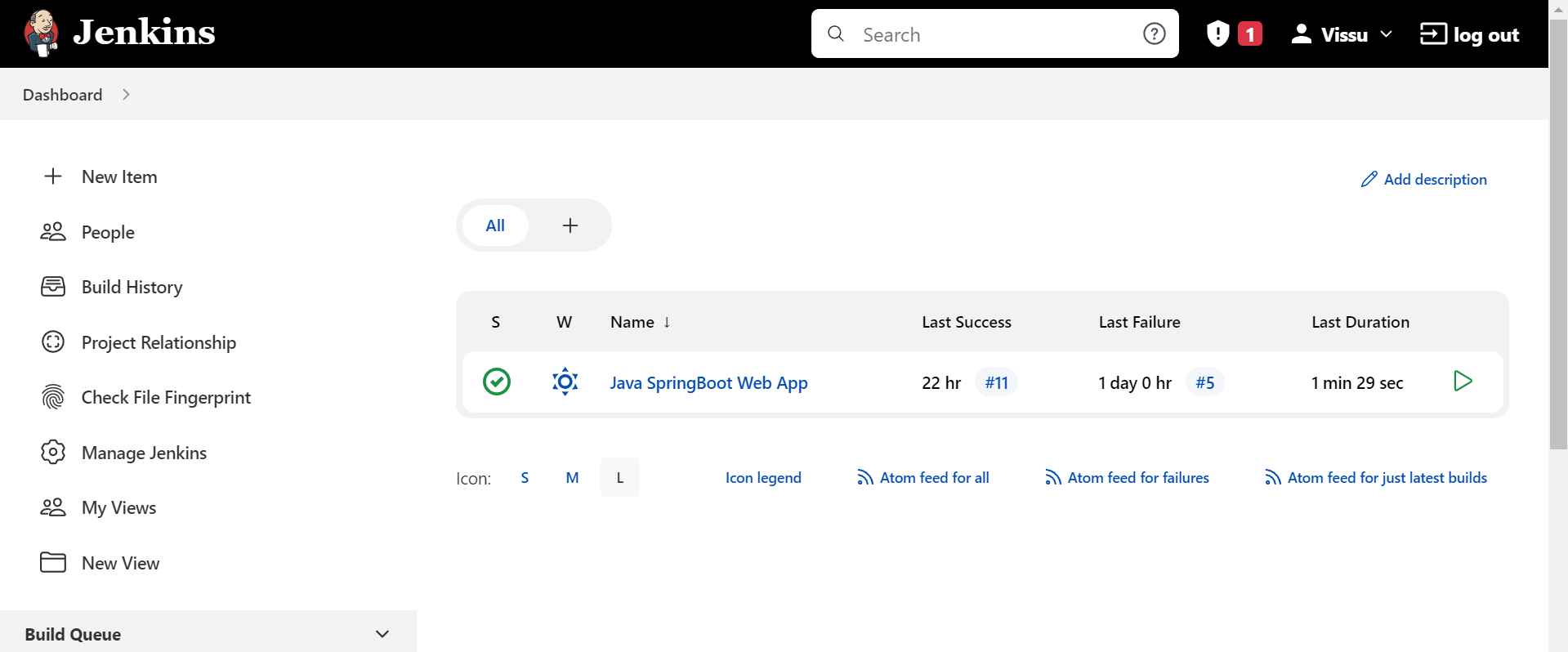

Go to manage jenkins

Go to Global Tool Configuration

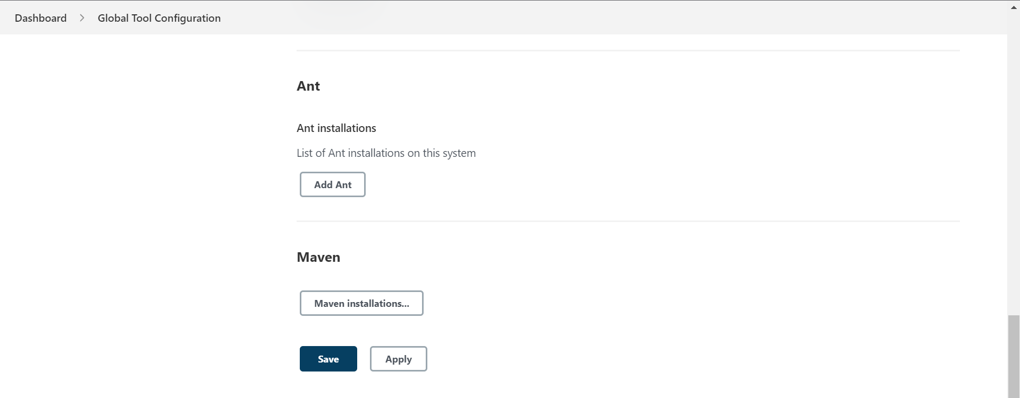

Click on Maven installations

Click on Add Maven

How to check MAVEN_HOME path

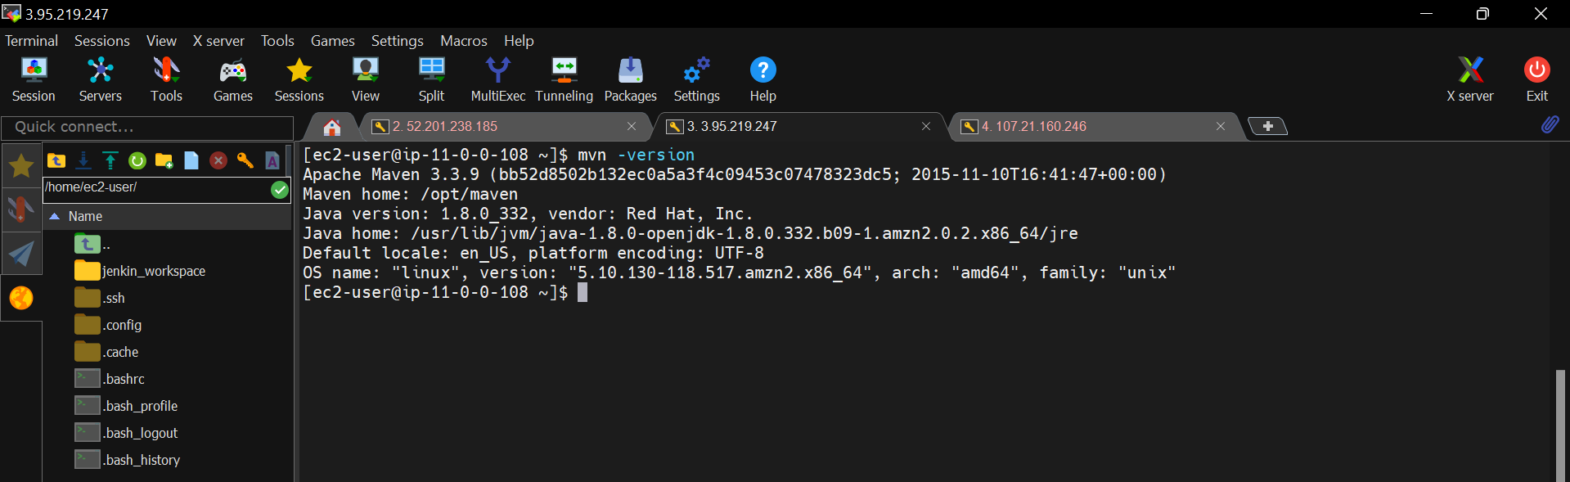

Copy this maven home path and enter in the above MAVEN_HOME box.

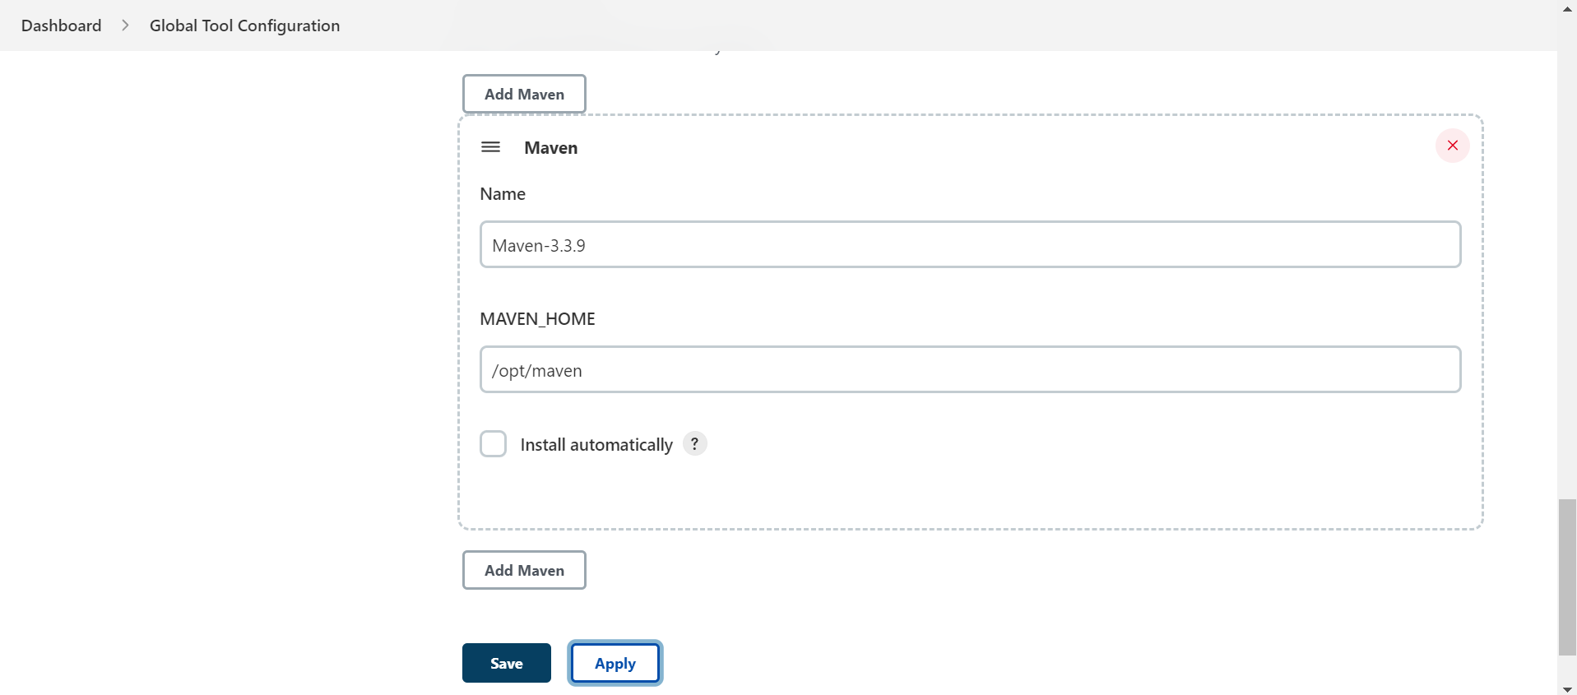

Click on apply and save.